B.P.H.E Society Ahmednagar
College Ahmednagar

SYBBA(CA) SEMESTER IV
SUBJECT: - PROJECT EVALUATION SHEET COURSE
Project Name-
Smart Data Mediator
NAME OF STUDENT: -
1: Gitanajli Arun Rede
ROLL NO: 84
TEACHER NAME: -
Madhvi Chavan Ma’am

Department Computer Science
CERTIFICATE
This is to certify that the project,
Smart Data Mediator
Has been completed successfully by-
Ritu Bhardwaj, Anjali Shinde
For the practical fulfilment of Department of computer Science as laid down by the Pune University during Academic Year 2025 -2026
Head of Department Project in charge Python
Internal Examiner’s External Examiner’s

Place: Ahmednagar Date:
Acknowledgement:
I would like to extend my heartful appreciation to everyone who played a role in the successful completion of the Smart Data Mediator project.
First and foremost ,my deepest thanks go to the “HOD[Head of the Department],Dr.Sayyed Razzak”,and my mentor “Mrs.Madhavi Dethe”,for their invaluable guidance ,unwavering support,and constructive feedback throughout the entire project development journey.Their expertise and encouragement were crucial in transforming the project from its initial idea into a fully realized system.
I am making this project not only for the good marks but also to increase my knowledge.
This project would not have been achievable without the collaboration and support of everyone involved,and for that,I am truly thankful.

Sr. No | Chapter | Page. No
1 | Abstract | 4
2 | Chapter 1.Introduction | 5-10
3 | Chapter 2.Requirement Analysis  2.1 Feasibility Study  2.2 Fact Finding Techniques  2.3 Project Requirement  2.3.1 Software/Hardware Specification | 11-21
4 | Chapter 3.System Design  3.1. E-R Diagram  3.2 Data Flow Diagram | 22-26
5 | Chapter 4.Data Dictionary | 27-28
6 | Chapter 5.Screens  5.1 Input Screens  5.2 Output Screens | 29-36
7 | Chapter 6.Testing  Test Steps, Data Validation Test Cases and result | 37-39
8 | Chapter 7.Limitations  7.1 Limitations  7.2 Future Enhancement | 40-41
9 | Chapter 8.Bibliography | 42
INDEX
SMART DATA MEDIATOR

Abstract

The Smart Data Mediator is a Flask-based intelligent data analysis and reporting system designed to bridge the gap between technical and non-technical users. The project provides an integrated environment where datasets can be uploaded, processed, queried, and visualized with ease. Unlike traditional BI tools that demand SQL knowledge or advanced Excel skills, this system leverages natural language processing (NLP) to let users ask questions in plain English.

The system supports multiple features such as dataset upload, preview, query processing, visualization generation, project management, and exportable reports (PDF/Excel). This enables organizations and students to explore data quickly, make decisions faster, and reduce dependency on technical experts

INTRODUCTION

Objective

The objective of the Smart Data Mediator is to simplify the process of querying and analyzing datasets. It allows users to interact with data through natural language, generate visual insights, and save reports for future reference.
- To provide a user-friendly data analysis system where queries can be written in natural language.
- To integrate visualizations (Bar, Line, Pie, Scatter) automatically from queries.
- To enable project management by saving previous queries and reports.
- To support export options like Excel and PDF for easy sharing.
- To bridge the gap between non-technical users and complex data systems.

Existing System
Traditional data analysis systems require technical expertise in SQL, Excel functions, or BI tools. Non-technical users face difficulties in extracting meaningful insights without specialized knowledge.
- Traditional tools like SQL, MS Excel, Power BI require expertise.
- Non-technical users often depend on developers or analysts.
- Limited real-time data exploration and poor accessibility.

Proposed System
The Smart Data Mediator provides an easy-to-use platform where users can upload datasets, ask questions in plain English, and receive instant results with visualizations. Reports are automatically stored, and users can export them in multiple formats {excel, pdf }
The Smart Data Mediator addresses these limitations by:
- Allowing dataset upload and preview.
- Supporting natural language queries using NLP (SpaCy).
- Generating instant data insights with charts.
- Storing projects and queries in a database for reuse.
- Exporting results in multiple formats.

Requirement Analysis

Feasibility Study

The system is technically feasible as it is built on widely used technologies such as Flask, Pandas, and SpaCy. Operational feasibility is ensured since it simplifies data analysis tasks. Economically, it is cost-effective as it uses open-source libraries.
- Technical Feasibility: Uses open-source libraries (Flask, Pandas, SpaCy, Matplotlib). Runs on any OS (Windows/Linux/Mac).
- Economic Feasibility: Cost-effective as no paid licenses are required.
- Operational Feasibility: Easy for non-technical users since the interface is simple and intuitive.
- Schedule Feasibility: Can be developed and deployed within a semester project timeframe.

Fact Finding Techniques
- Observation: Collected problems faced by students and teachers using Excel.
- Interviews: Discussed with faculty about difficulties in data analysis.
- Record Review: Reviewed past student reports to identify gaps.

Project Requirements

Software Requirements
- Python 3.10+
- Flask 3.0+
- Pandas, OpenPyXL, ReportLab
- SpaCy (for NLP)
- HTML, CSS, JavaScript (Frontend)

Hardware Requirements
- Processor: Intel i5 or higher
- RAM: 8 GB minimum
- Storage: 1 GB free disk space
- OS: Windows/Linux/MacOS

System Design
The system is designed using ERD and Flowchart diagrams.
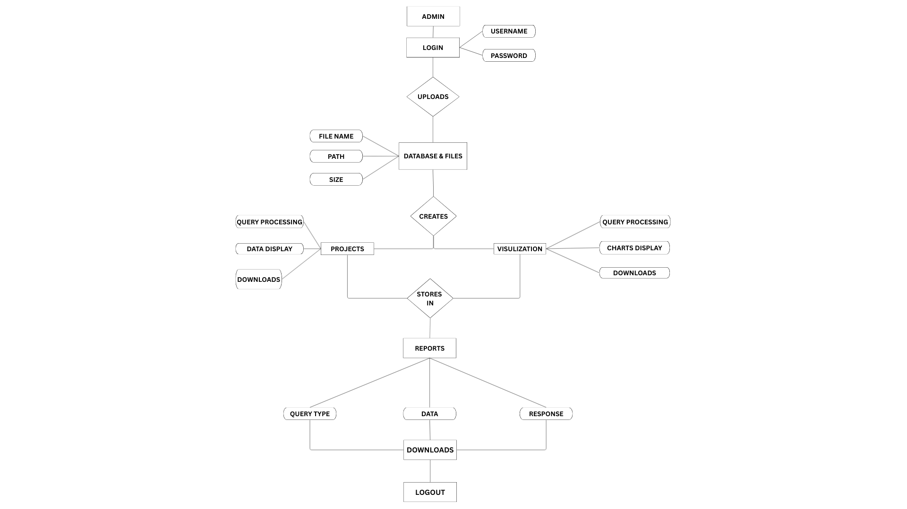
Entity Relationship Diagram (ERD)

Flowchart:

DFD LEVEL 0

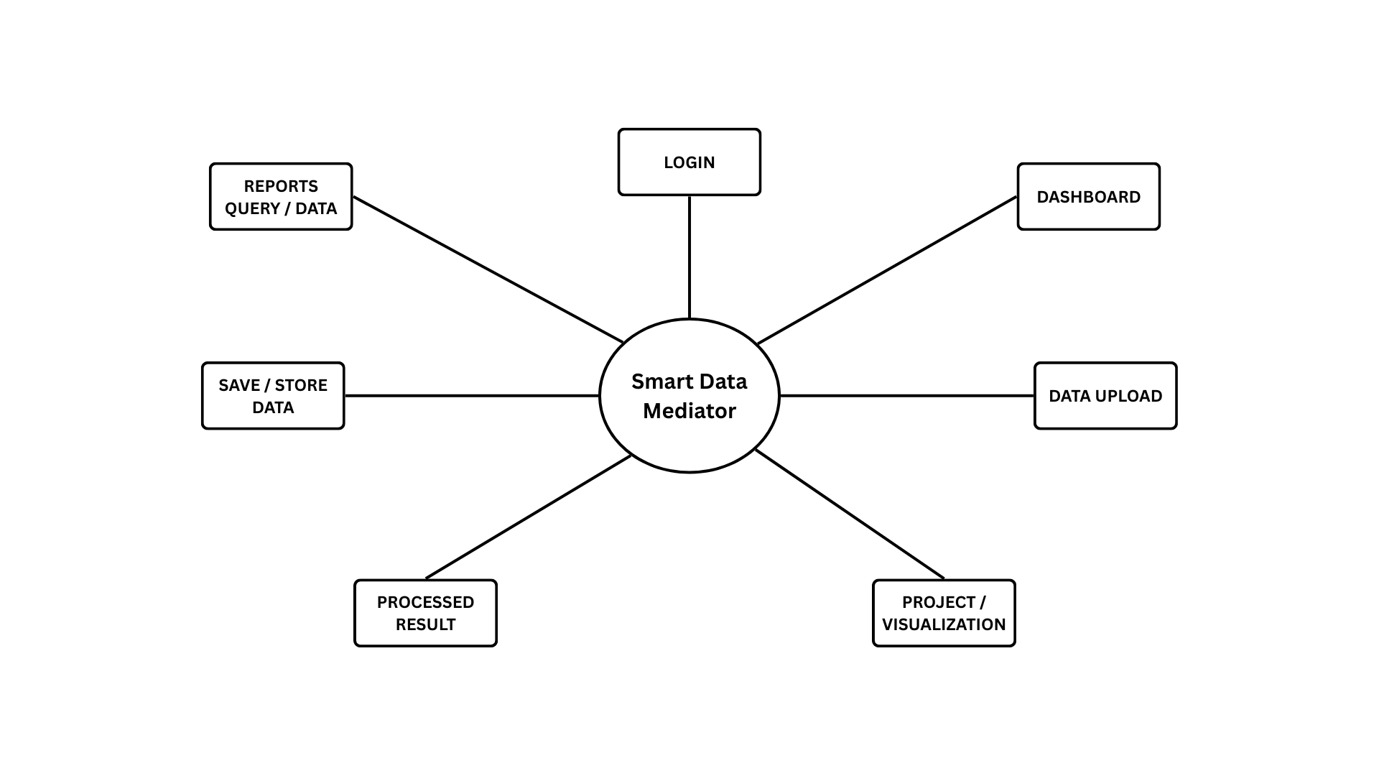

DFD LEVEL 1

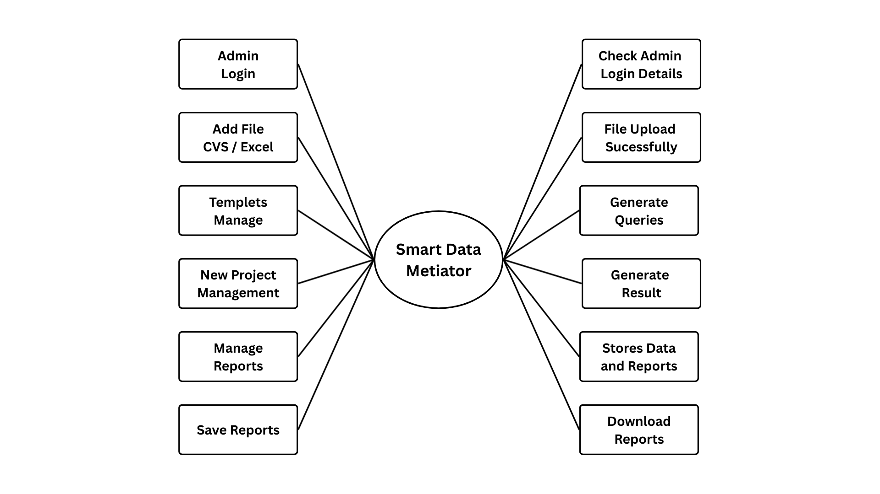

DFD LEVEL 2
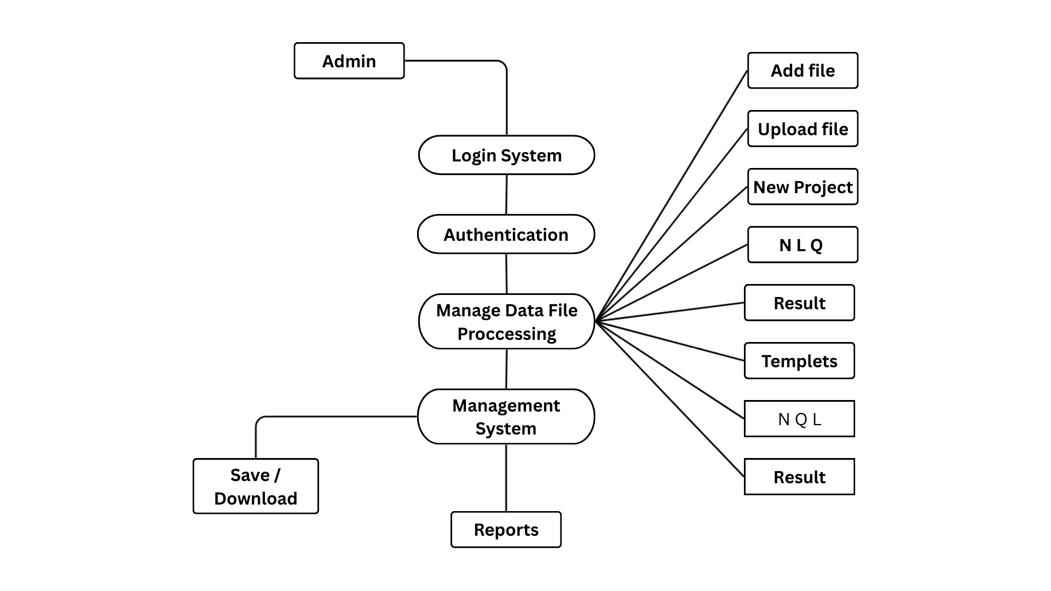

Data Dictionary

User Table
Attribute name | Data type | constraints
user_id | INT | NOT NULL
username | VARCHAR(50) | NOT NULL
password | VARCHAR(255) | NOT NULL
role | VARCHAR(20) | NOT NULL
create_at | DATETIME | NOT NULL

Upload Table
Attribut name | Data type | Constraints
upload-id | INT | NOT NULL
user-id | INT | NOT NULL
filename | VARCHAR(255) | NOT NULL
path | VARCHAR(255) | NOT NULL
size | INT | NOT NULL
data_uploaded | DATETIME | NOT NULL

Project Table
Attribute name | Data type | constraints
project_id | INT | NOT NULL
user_id | INT | NOT NULL
name | VARCHAR(100) | NOT NULL
Path | VARCHAR(255) | NOT NULL
Attribute name | Data type | constraints
created_at | DATETIME | NOTNULL
Visualization Table
Attribute name | Data type | constraints
version | INT | NOT NULL
Project_id | INT | NOT NULL
version_number | VARCHAR(10) | NOT NULL
date | JSON | NULLABLE
created_at | DATETIME | NOTNULL

Report Table
Attribute name | Data type | constraints
rport_id | INT | NOT NULL
User_id | INT | NOT NULL
query | TEXT | NOTABLE
response | TEXT | NOTABLE
type | VARCHAR(50) | NOT NULL
timestamp | DATETIME | NOTNULL
file | VARCHAR(255) | NULLABLE

Test cases
Data Testing is checking the tables data of the database. The Stored Procedure provides the end-user with the Expected result. Adding, Updating, Deleting of Data is Performed. Functional Testing verifies that the software performs its stated functions in a way that the users expect.
Test Case ID | Test Case Name | Description | Steps | Input | Expected Result | Actual Result | Status
TCDM01 | Login_Valid_Credentials | User should be able to log in with valid credentials | 1. Enter valid username & password.  2. Click 'Login'. | Username: ritu  Password: 12345 | Redirect to dashboard. | Redirected to dashboard. | Pass
TCDM02 | Login_Invalid_Credentials | User should not be able to log in with invalid credentials | 1. Enter wrong username or password.  2. Click 'Login'. | Username: abc  Password: wrong | Error message should appear. | Error message displayed. | Pass
TCDM03 | File_Upload_Valid | System should accept valid Excel/CSV upload | 1. Click 'Upload'.  2. Select a valid Excel/CSV file. | sales_data.csv | File should be uploaded and preview displayed. | Preview displayed. | Pass
TCDM04 | File_Upload_Invalid | System should reject unsupported file formats | 1. Click 'Upload'.  2. Select a .txt file. | notes.txt | Error message: Invalid file format. | Error message displayed. | Pass
TCDM05 | Query_Processing | System should process simple query correctly | 1. Enter query: 'show first 5 rows'.  2. Click 'Submit'. | Query text | First 5 rows should be displayed. | First 5 rows displayed. | Pass
TCDM06 | Visualization_BarChart | User should be able to generate a bar chart | 1. Upload dataset.  2. Select 'Bar Chart'.  3. Provide fields. | X: Category  Y: Sales | Bar chart should be displayed. | Bar chart displayed. | Pass
TCDM07 | Visualization_Invalid | Chart should not generate without required fields | 1. Upload dataset.  2. Select 'Bar Chart' without fields. | Empty fields | Error message: Please select fields. | Error message displayed. | Pass
TCDM08 | Save_Project | User should be able to save a project | 1. Run query & visualization.  2. Click 'Save Project'. | Project Name: Sales Analysis | Project should be saved. | Project saved. | Pass
TCDM09 | Export_Report | User should be able to export | 1. Run analysis. | Click Export | PDF report should download. | PDF downloaded. | Pass

System Screens
The following screenshots illustrate the Smart Data Mediator interface:
Input screens:

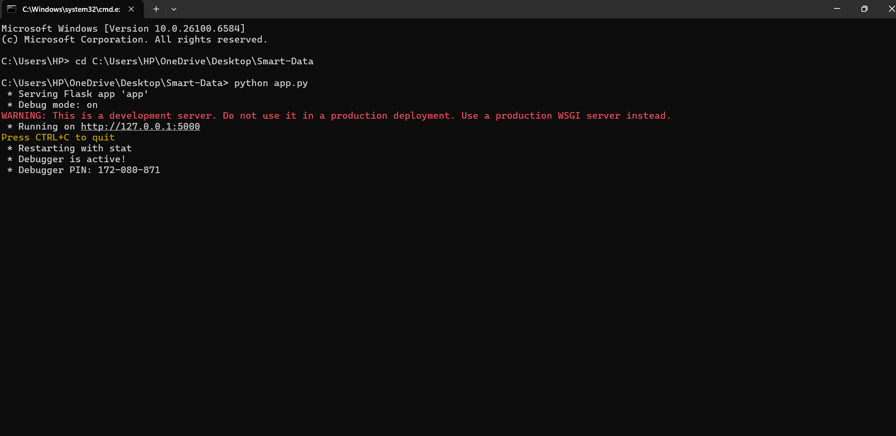
Starting of the sever:
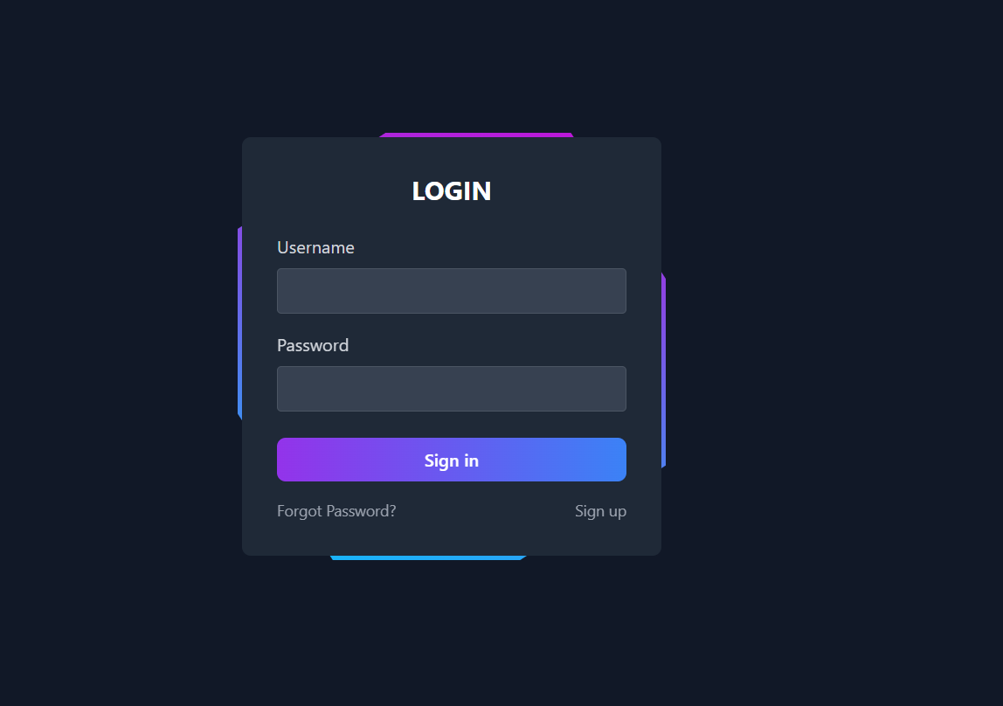
Login Page:

Dashboard:
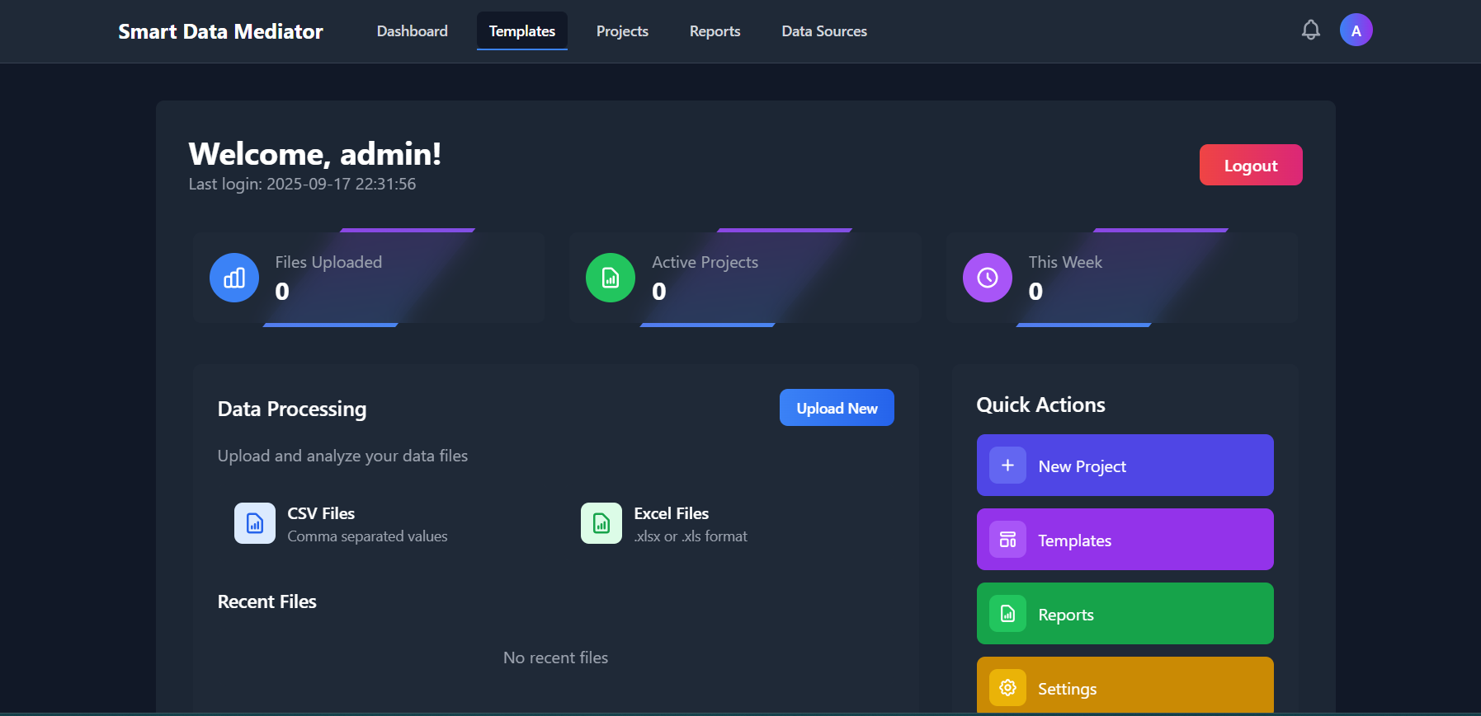
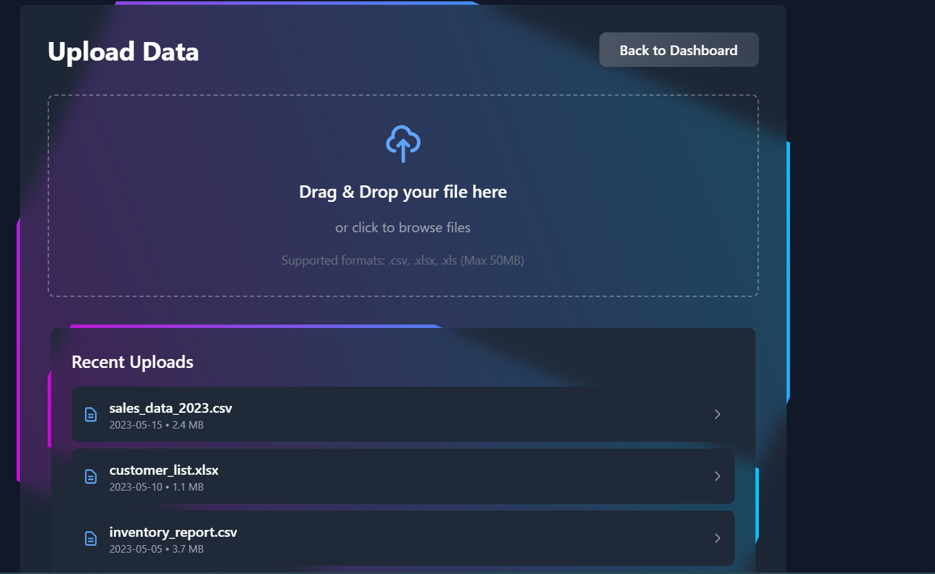
Upload File:

New Project Query Processing:
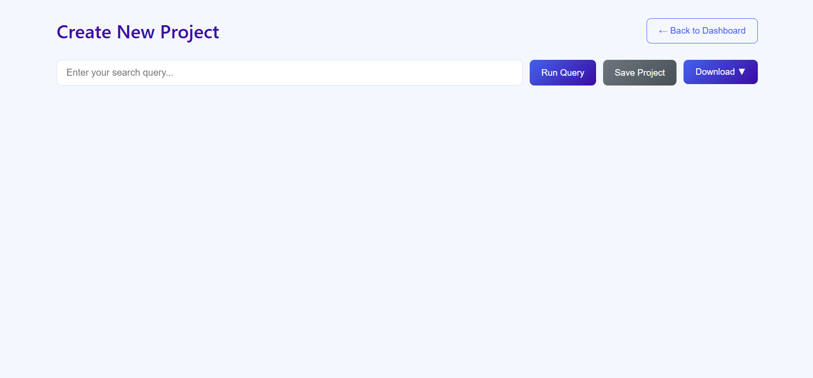
Visualization Process:
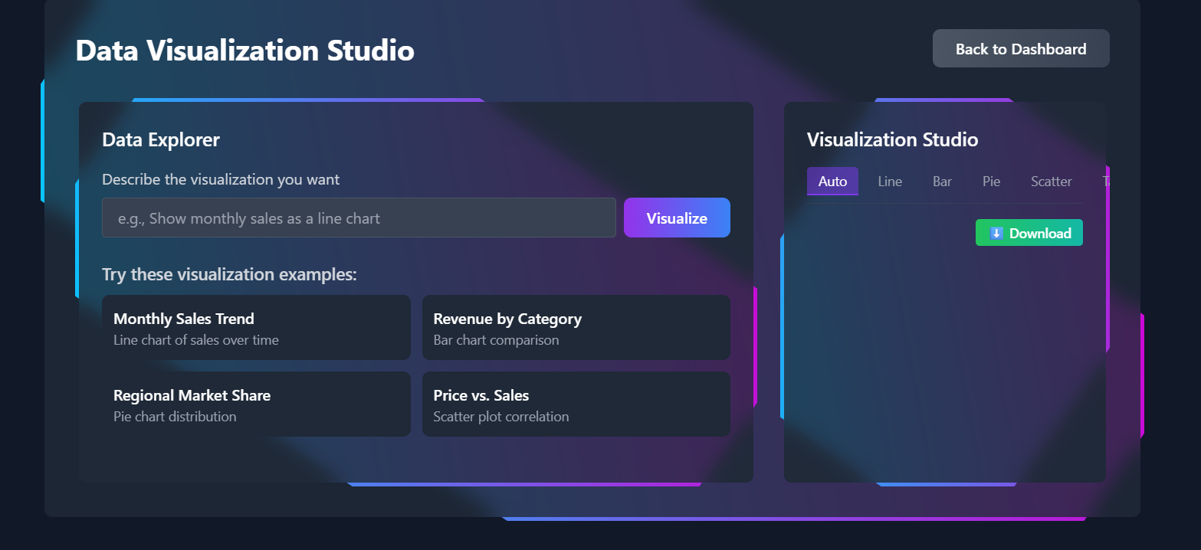

Reports Saving:
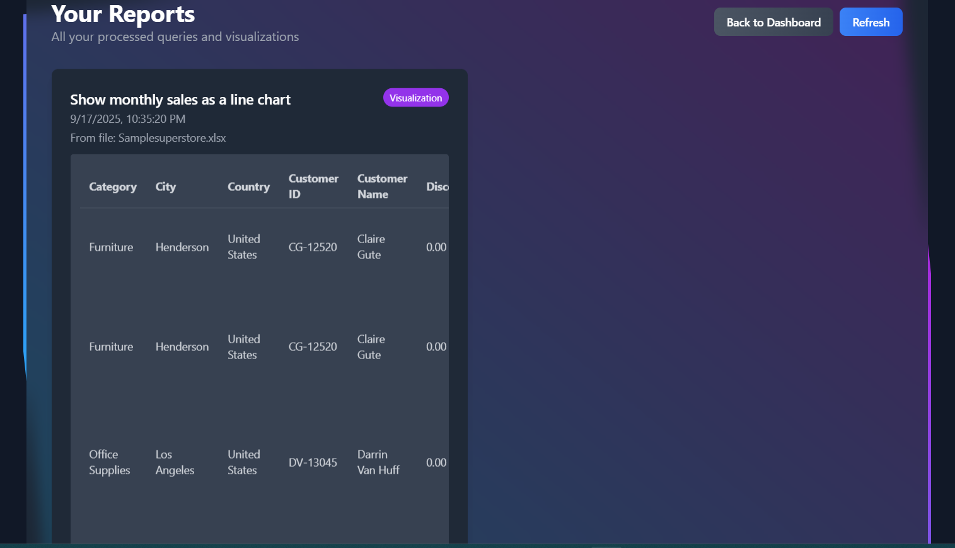
Output screens:
Dashboard:


File Uploaded:
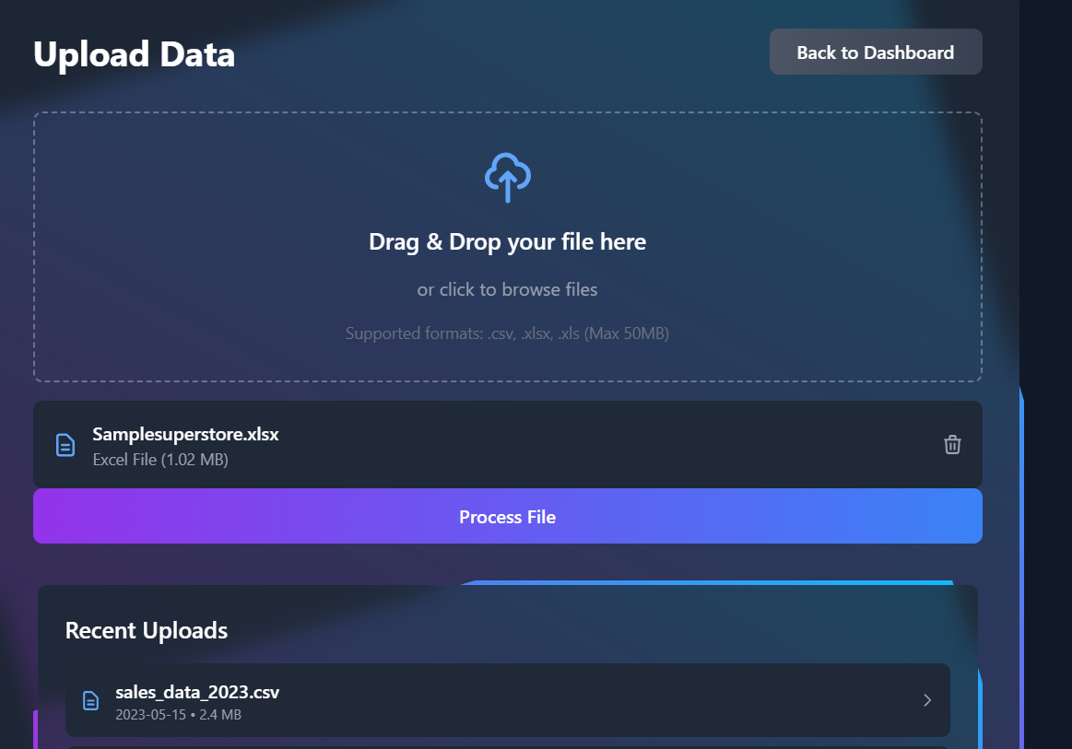
Query Result:
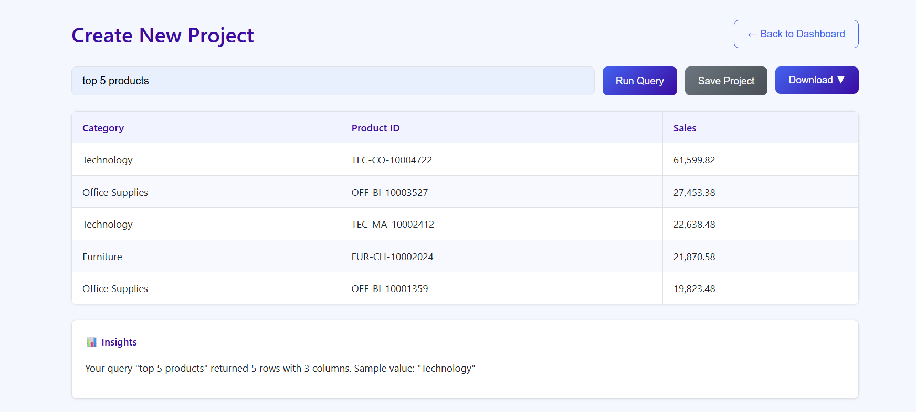

Visualization Result:
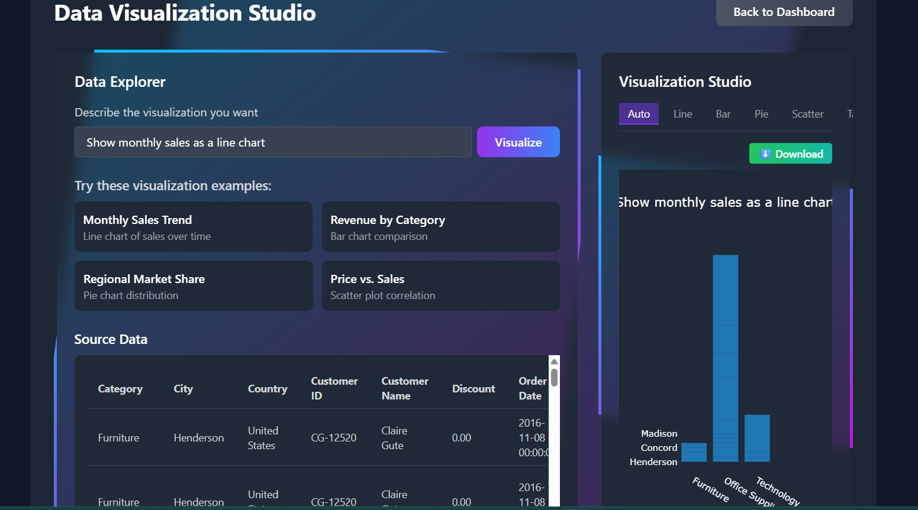

Reports Download {CVS, Excel, PDF}:

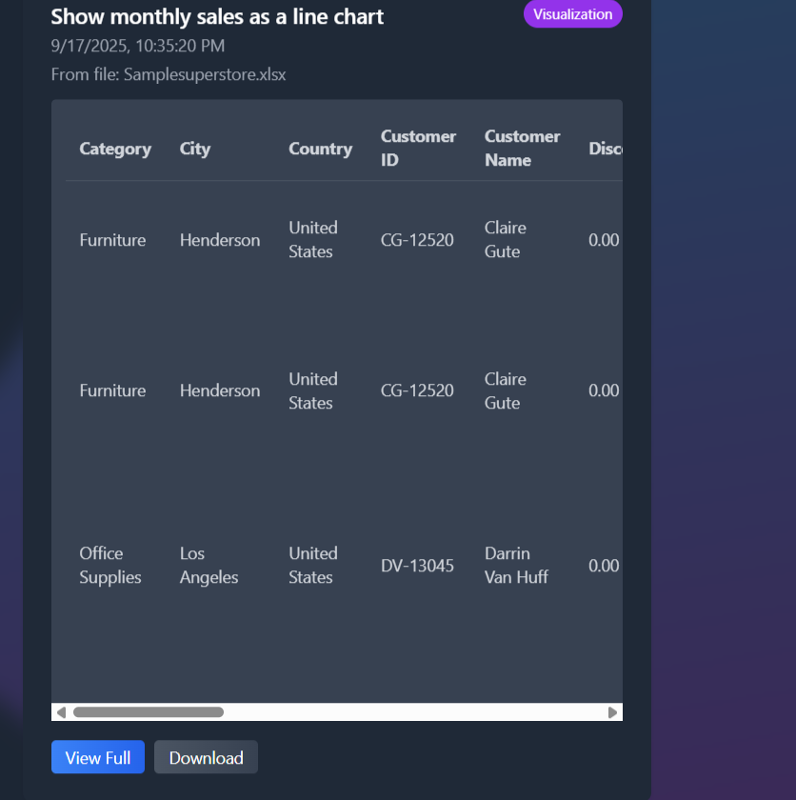

System Testing
The system has been tested using functional and validation test cases:
1. Login validation
2. File upload testing (CSV/Excel)
3. Query processing validation
4. Report saving and retrieval
5. Export functionality (CSV, Excel, PDF, HTML)

Limitations and Future Enhancements
Limitations:
- NLP understanding is limited to predefined patterns.
- Reports are stored locally, not on cloud.
Future Enhancements:
- Cloud storage integration
- Advanced AI query understanding
- Real-time collaboration
- Role-based access control
- Multiple dataset merging and linking

Bibliography
- Flask Documentation
- Pandas Documentation
- SpaCy NLP Toolkit
- ReportLab PDF Toolkit
- OpenPyXL Excel Toolkit
THANK TOU…

